1. (NUMBER Didn’t work when making the table so I used numeric but it shows up as decimal data type anyway.)

CREATE TABLE SALES_REP (REP_NUM CHAR(2) PRIMARY KEY, LAST_NAME VARCHAR(15), FIRST_NAME CHAR(15), STREET CHAR(15), CITY CHAR(15), STATE CHAR(2), POSTAL_CODE CHAR(5), COMMISSION NUMERIC(7,2), RATE NUMERIC(3,2));

1. INSERT INTO SALES_REP VALUES ('35','Lim','Louise','535 Vincent Dr.','Grove','CA','90092',0.00,0.05);

1. DROP TABLE SALES_REP;

1. mysql> \. C:\Users\Chuck\Desktop\COP 2700\TAL Distributors script file
2. 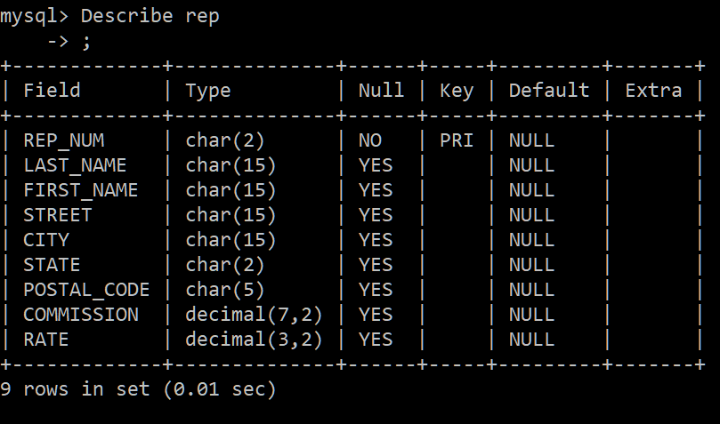

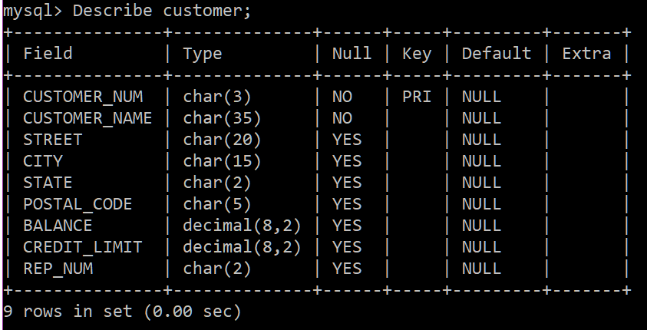

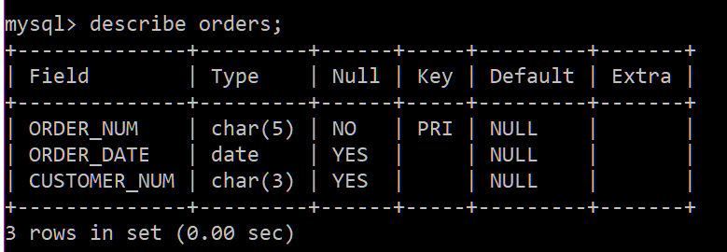

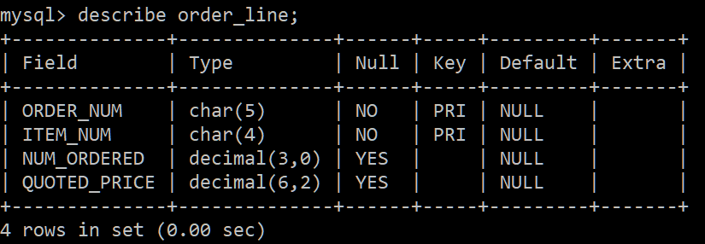

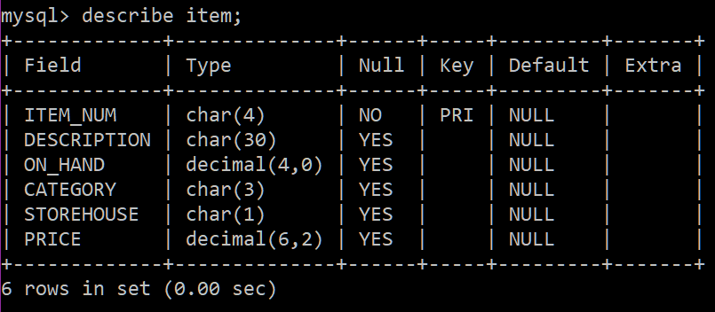

1. 